Population of 65+ and 85+ - current and change
31 March 2021
11:17

Why is this subject important for health and wellbeing?
https://jsna.westsussex.gov.uk/ageing-well/

94,000 aged 65-74
89,000 aged 75+

Older population in WSx projected to grow

The demographic breakdown of the population will drive demand for services

Who is affected?
Older adults

Are some people more at risk than others? Does this vary across areas?

Nope - we're all getting older

How is it measured?
(Where possible include scale within the county)

What is the direction of travel?
Counting!!

https://ws-jsna.github.io/ageing-well/
In 2039, more than 30% of the population are projected to be aged 65 or older

https://jsna.westsussex.gov.uk/core/population-data/estimates/
Population pyramid
Internal migration - around 1500/year retire into West Sussex

http://www.plumplot.co.uk/West-Sussex-population.html
Population average age map…mean age in WSx =43.3

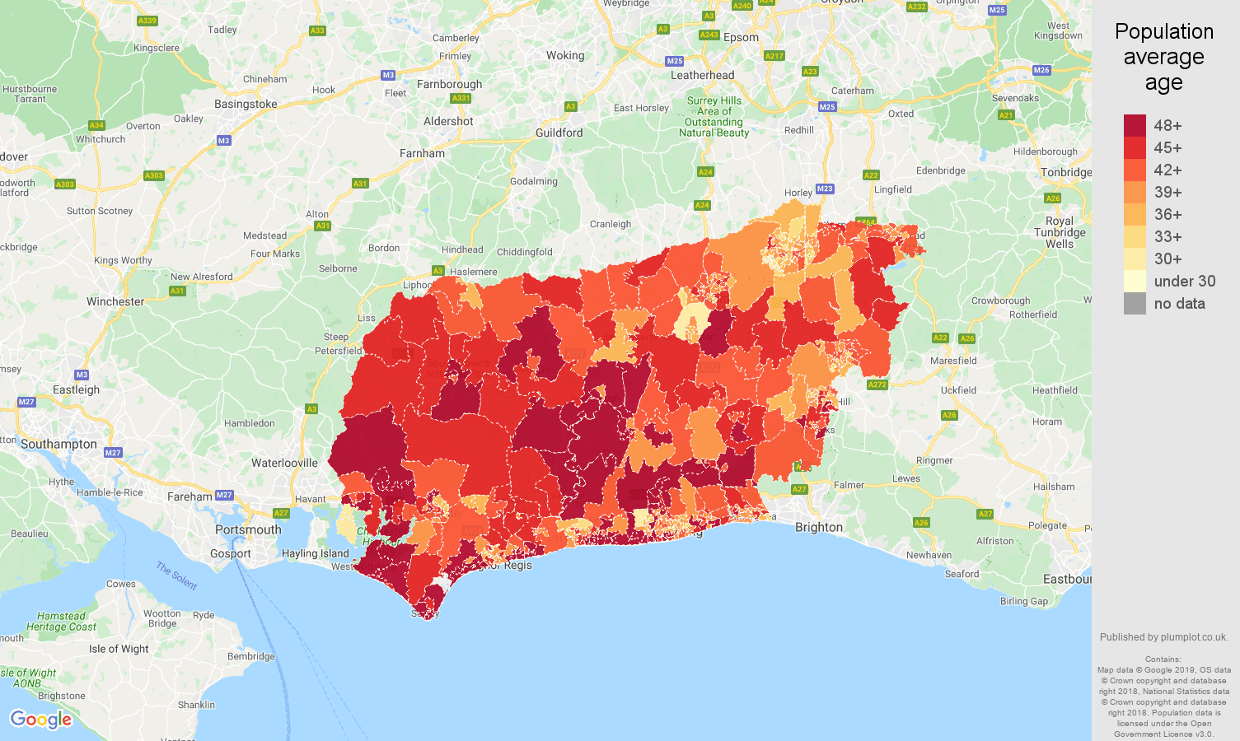

From <http://www.plumplot.co.uk/West-Sussex-population.html>

More up to date pop pyramid

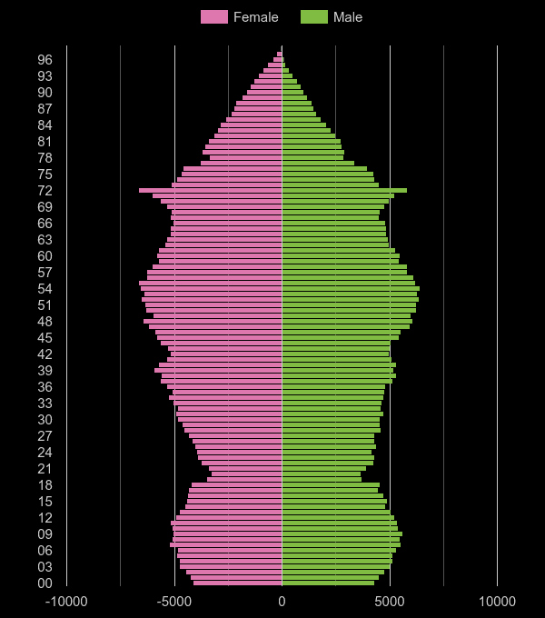

From <http://www.plumplot.co.uk/West-Sussex-population.html>

Some very groovy charts!!

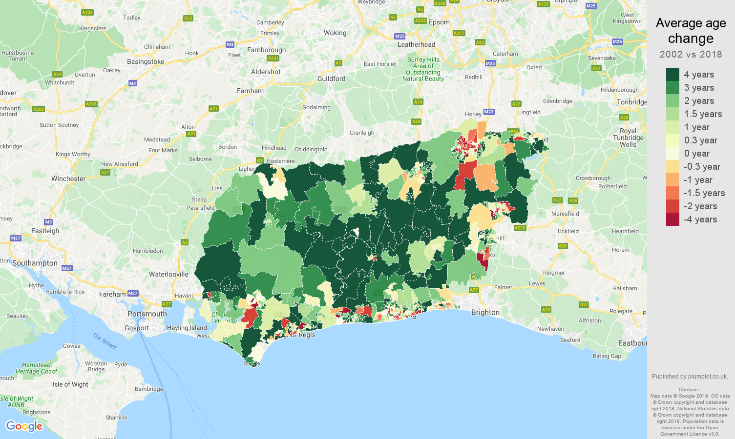

From <http://www.plumplot.co.uk/West-Sussex-population-changes.html>

Are there interventions to tackle the problem that are known to be effective? Is anything being done in West Sussex?
Also, what do we know at sub-county level, e.g. Ds&Bs, PCNs

Sources
Also note any gaps in knowledge

Key reports
(PHE reports, key and recent evidence)

People with long-term conditions and co-morbidities
31 March 2021
11:20

Why is this subject important for health and wellbeing?

The number of people living with long term conditions will have a direct impact on health care need and utilisation

Who is affected?
https://ws-jsna.github.io/assets/ageing-well/West-Sussex-JSNA-Older-People-Profiling.pdf
P7 - people with a limiting long term illness projected to 2029 - according to the 2011 census…
- 35000 people aged 65 and older have a long term limiting illness which limits their daily activities a lot- expected to increase to 50730 by 2029
- 46710 - limits their daily activities a little - expected to increase to 64810 by 2029

Also https://fingertips.phe.org.uk/indicator-list/view/NnItYiPSX0#page/0/gid/1/pat/6/ati/102/are/E10000032/iid/212/age/1/sex/4/cid/4/tbm/1
Individuals with…
- Asthma
- Cancer
- COPD
- Coronary heart disease
- Diabetes - nearly 24500 over 65s estimated to have diabetes…expected to increase to 27560 by 2029
- Epilepsy
- Heart failure
- Hypertension 2019/20 - 15.7
- Stroke 2019/20 - 2.1
- Dementia - 15500 with dementia - expected to increase to 20310 by 2029

Are some people more at risk than others? Does this vary across areas?

Family history etc…
lifestyle

How is it measured?
(Where possible include scale within the county)

What is the direction of travel?

Prevalence/incidence data

https://fingertips.phe.org.uk/indicator-list/view/NnItYiPSX0#page/0/gid/1/pat/6/ati/102/are/E10000032/iid/212/age/1/sex/4/cid/4/tbm/1

Are there interventions to tackle the problem that are known to be effective? Is anything being done in West Sussex?
Also, what do we know at sub-county level, e.g. Ds&Bs, PCNs

Social prescribing
Wellbeing hubs

Sources
Also note any gaps in knowledge

Undiagnosed cases?

Key reports
(PHE reports, key and recent evidence)

https://www.kingsfund.org.uk/projects/time-think-differently/trends-disease-and-disability-long-term-conditions-multi-morbidity

https://www.england.nhs.uk/ourwork/clinical-policy/ltc/

Specific conditions - sensory impairment
31 March 2021
11:20

Why is this subject important for health and wellbeing?

Individuals with sight and/or hearing loss have additional and unique needs compared to the general population

https://www.westsussexconnecttosupport.org/how-to-live-well-with-a-health-condition-or-disability/sensory-impairment/

Who is affected?

Those with a visual and/or auditory impairment, their family and carers…..people they work with/for….everyone?

https://ws-jsna.github.io/assets/ageing-well/West-Sussex-JSNA-Older-People-Profiling.pdf
P11 - 18060 over 65s with visual impairment - expected to increase to 22510 by 2029
88700 over 65s with a moderate/severe hearing impairment - 113180 by 2029; 2430 with profound hearing loss - 3100 by 2029

Are some people more at risk than others? Does this vary across areas?

Congenital conditions…
People in "loud" jobs?

How is it measured?
(Where possible include scale within the county)

What is the direction of travel?

increasing
Databases/registries

Are there interventions to tackle the problem that are known to be effective? Is anything being done in West Sussex?
Also, what do we know at sub-county level, e.g. Ds&Bs, PCNs

Sources
Also note any gaps in knowledge

RNIB etc….not all cases will be recorded/diagnosed

Key reports
(PHE reports, key and recent evidence)

https://www.rnib.org.uk/sites/default/files/SEND%20Commissioners%20advice%20report.pdf

Estimating care needs in the population - segmentation
31 March 2021
11:21

Why is this subject important for health and wellbeing?

Who is affected?

Are some people more at risk than others? Does this vary across areas?

How is it measured?
(Where possible include scale within the county)

What is the direction of travel?

https://jsna.westsussex.gov.uk/assets/ageing-well/Estimation-of-Need-and-Social-Care-Demand-Management-West-Sussex-PH.pdf

Are there interventions to tackle the problem that are known to be effective? Is anything being done in West Sussex?
Also, what do we know at sub-county level, e.g. Ds&Bs, PCNs

Sources
Also note any gaps in knowledge

Key reports
(PHE reports, key and recent evidence)

Self-care and self-management - Patient survey data and ASCOF
31 March 2021
11:21

Why is this subject important for health and wellbeing?
Adult social care outcomes framework - measures how well care and support services achieve the outcomes that matter most to people

Power BI



Who is affected?

Are some people more at risk than others? Does this vary across areas?

How is it measured?
(Where possible include scale within the county)

What is the direction of travel?

https://lginform.local.gov.uk/reports/view/lga-research/lga-research-report-adult-social-care-outcomes-framework-for-england-ascof-single-council-detailed-report?mod-area=E10000032&mod-group=AllCountiesInCountry_England&mod-type=namedComparisonGroup

Includes data and year on year graphs

https://lginform.local.gov.uk/reports/view/matthew-king/ascof-west-sussex-1

Are there interventions to tackle the problem that are known to be effective? Is anything being done in West Sussex?
Also, what do we know at sub-county level, e.g. Ds&Bs, PCNs

Sources
Also note any gaps in knowledge

Key reports
(PHE reports, key and recent evidence)

Social care demand
31 March 2021
11:21

Why is this subject important for health and wellbeing?
Informs commissioning and budgetary decisions

£195million
Our adult social care budget for 2018/2019 is £195million, which is 37% of the total council budget. We are spending more on adult social care each year, which is putting a strain on our budget.

Who is affected?

Are some people more at risk than others? Does this vary across areas?

How is it measured?
(Where possible include scale within the county)

What is the direction of travel?

Are there interventions to tackle the problem that are known to be effective? Is anything being done in West Sussex?
Also, what do we know at sub-county level, e.g. Ds&Bs, PCNs

Sources
Also note any gaps in knowledge

Key reports
(PHE reports, key and recent evidence)
https://www.westsussexconnecttosupport.org/Resources/FileStorage/EventAdditionalFieldsFiles/2abdfe75-0316-46bf-aab4-a1f600f4882f/c0d2e6c9-7e7a-41be-918e-6e3042afcd33_AS_vision_strategy_2019_2021.pdf

Falls and mobility
31 March 2021
11:22

Why is this subject important for health and wellbeing?

Falls related injuries in people aged 65 and over account for around 4,772 emergency hospital admissions each year in West Sussex.

From <https://www.westsussex.gov.uk/campaigns/preventing-falls/>

Falls and fractures in older people are often preventable. Reducing falls and fractures is important for maintaining the health, wellbeing and independence of older people.
A fall is defined as an event which causes a person to, unintentionally, rest on the ground or lower level, and is not a result of a major intrinsic event (such as a stroke) or overwhelming hazard. Having a fall can happen to anyone; it is an unfortunate but normal result of human anatomy. However, as people get older, they are more likely to fall over. Falls can become recurrent and result in injuries including head injuries and hip fractures.
The causes of having a fall are multifactorial – a fall is the result of the interplay of multiple risk factors. These include:
- muscle weakness
- poor balance
- visual impairment
- polypharmacy – and the use of certain medicines
- environmental hazards
- some specific medical conditions, which might make a person more likely to fall
Falls are events resulting from the presence of risk factors. The likelihood and severity of injury resulting from an event is related to a number of possible factors including bone health, risk of falls, frailty and low weight. Strong bones are important for your health. People with low bone mineral density are more likely to experience a fracture following a fall. Osteoporosis is one of the reasons why people have low bone mineral density.

From <https://www.gov.uk/government/publications/falls-applying-all-our-health/falls-applying-all-our-health>

Who is affected?

Are some people more at risk than others? Does this vary across areas?

How is it measured?
(Where possible include scale within the county)

What is the direction of travel?

https://fingertips.phe.org.uk/profile/healthy-ageing/data#page/0/gid/1938133252/pat/6/ati/102/are/E10000032/iid/22401/age/27/sex/4/cid/4/tbm/1/page-options/ovw-do-0

2019/20
- Emergency hospital admissions due to falls in 65+ = 2521
- 65-79 = 1134
- 80+ = 6542
- Hip fractures in 65+ = 571
- 65-79 = 237
- 80+ = 1539
- Osteoporosis QOF prevalence (50+) = 0.9

Are there interventions to tackle the problem that are known to be effective? Is anything being done in West Sussex?
Also, what do we know at sub-county level, e.g. Ds&Bs, PCNs

The super six
https://www.westsussex.gov.uk/media/12468/ws32429-0219-falls-prevention-folded-booklet.pdf
https://www.westsussex.gov.uk/campaigns/preventing-falls/

Sources
Also note any gaps in knowledge

Key reports
(PHE reports, key and recent evidence)

https://jsna.westsussex.gov.uk/assets/ageing-well/Falls-Summer-2017-v3.pdf

Admissions to hospital and emergency admissions
31 March 2021
11:22

Why is this subject important for health and wellbeing?

Who is affected?

Are some people more at risk than others? Does this vary across areas?

How is it measured?
(Where possible include scale within the county)

What is the direction of travel?

Are there interventions to tackle the problem that are known to be effective? Is anything being done in West Sussex?
Also, what do we know at sub-county level, e.g. Ds&Bs, PCNs

Sources
Also note any gaps in knowledge

Key reports
(PHE reports, key and recent evidence)

Immunisations
31 March 2021
11:22

Why is this subject important for health and wellbeing?

Who is affected?
65 - pneumococcal (23 serotypes)
65+ - annual influenza
70 - shingles

Are some people more at risk than others? Does this vary across areas?

How is it measured?
(Where possible include scale within the county)

What is the direction of travel?

Flu vax uptake in over 65s 2019/20 - 72.4%....little change since 2015/16
2020/21 - 83.7% uptake in over 65s https://www.gov.uk/government/statistics/seasonal-flu-vaccine-uptake-in-gp-patients-monthly-data-2020-to-2021

Shingles uptake - 2020/21 = 27.4% https://www.gov.uk/government/publications/herpes-zoster-shingles-immunisation-programme-2020-to-2021-evaluation-reports

https://wsx-c19-mobile.netlify.app/ 65+ covid vaccine uptake = 95.7%

Are there interventions to tackle the problem that are known to be effective? Is anything being done in West Sussex?
Also, what do we know at sub-county level, e.g. Ds&Bs, PCNs

Sources
Also note any gaps in knowledge

Key reports
(PHE reports, key and recent evidence)

Care home residents
31 March 2021
11:23

Why is this subject important for health and wellbeing?

Who is affected?

Are some people more at risk than others? Does this vary across areas?

How is it measured?
(Where possible include scale within the county)

What is the direction of travel?

Are there interventions to tackle the problem that are known to be effective? Is anything being done in West Sussex?
Also, what do we know at sub-county level, e.g. Ds&Bs, PCNs

Sources
Also note any gaps in knowledge

Key reports
(PHE reports, key and recent evidence)

End of Life care and Place of death
31 March 2021
11:23

Why is this subject important for health and wellbeing?

Who is affected?

Are some people more at risk than others? Does this vary across areas?

How is it measured?
(Where possible include scale within the county)

What is the direction of travel?

https://fingertips.phe.org.uk/profile/end-of-life/data#page/1/gid/1938132883/pat/6/ati/302/are/E10000032/iid/93474/age/1/sex/4/cid/4/tbm/1

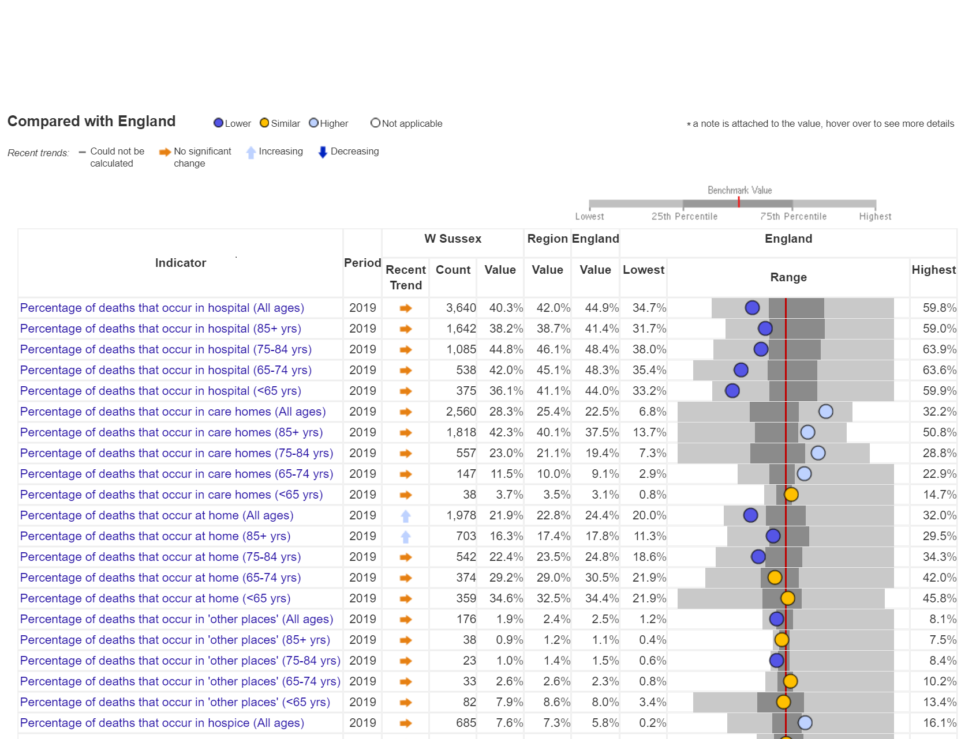

Are there interventions to tackle the problem that are known to be effective? Is anything being done in West Sussex?
Also, what do we know at sub-county level, e.g. Ds&Bs, PCNs

Sources
Also note any gaps in knowledge

Key reports
(PHE reports, key and recent evidence)

Underlying cause of death
27 April 2021
11:03
9064 deaths in West Sussex in 2019; female population outlives male
<<Deaths WS and D.Bs - ONS.xlsx>>

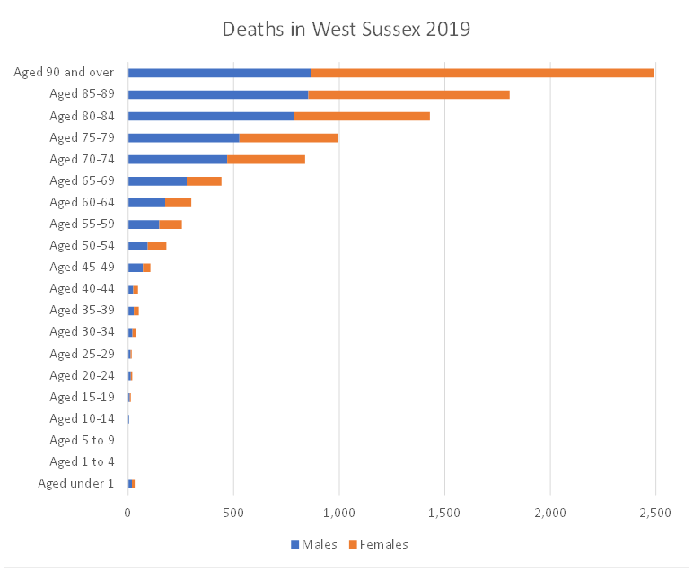

(as in the 2019 JSNA summary), cancers and diseases of the circulatory and respiratory systems account for nearly 65% of deaths (68.5% in males and 60.5% in females).
- Fairly even split between males and females for most causes of death, although deaths caused by cancers and circulatory system diseases make up a slightly greater proportion of the deaths in males, compared to females (combined, 55.8% vs. 48.5%).
- Deaths with an underlying cause of mental and behavioural disorders account for nearly double the percentage of deaths in females as males (12.5% vs. 6.8%). Looking at sub-groups in this category, dementias account for >95% of deaths in both sexes.
- Similarly, females had just over double the proportion of deaths classified as other compared to males (5.1% vs. 2.2%). Of these, 'senility' accounted for a third of females and nearly a quarter of males - presumably this and the dementia proportion reflects women living longer than men?
- (and interestingly, in the other category, all sudden infant death syndrome deaths (n=5) were in males - v. small numbers but would be vaguely interesting to see if this is repeated in previous years)

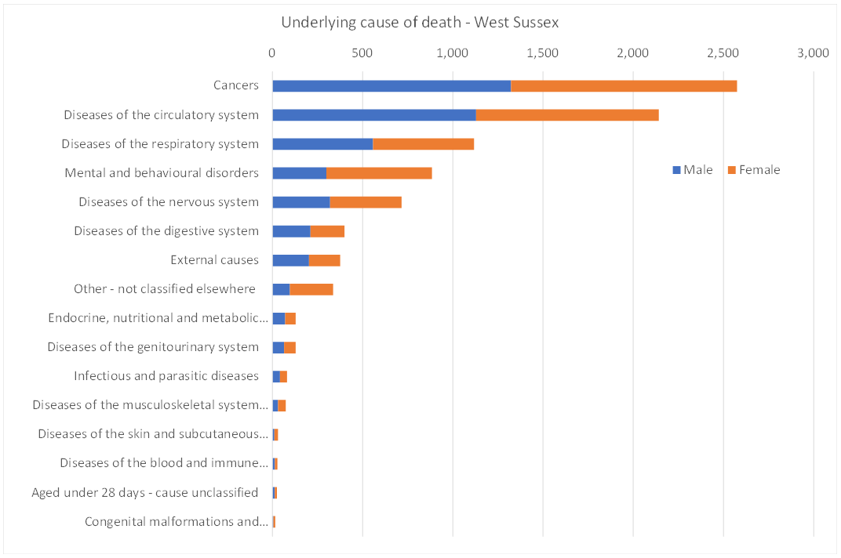

Why is this subject important for health and wellbeing?

Who is affected?

Are some people more at risk than others? Does this vary across areas?

Are there interventions to tackle the problem that are known to be effective? Is anything being done in West Sussex?
Also, what do we know at sub-county level, e.g. Ds&Bs, PCNs

How is it measured?
(Where possible include scale within the county)

What is the direction of travel?

https://fingertips.phe.org.uk/profile/end-of-life/data#page/1/gid/1938132882/pat/6/par/E12000008/ati/302/are/E10000032/cid/4/tbm/1

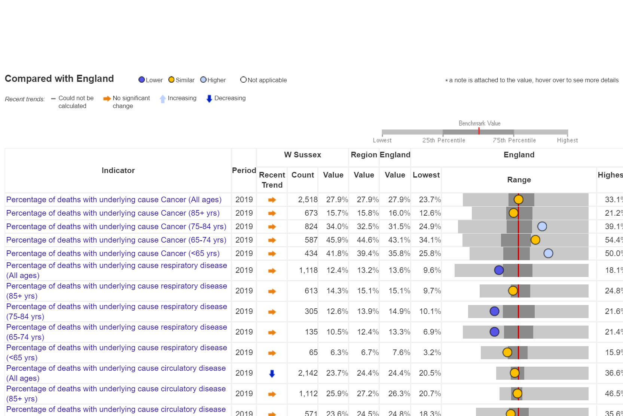

Key reports
(PHE reports, key and recent evidence)

Sources
Also note any gaps in knowledge

Older workers during Covid
04 May 2021
10:21

Today the Ageing Analysis team in the ONS Centre for Ageing and Demography have released

Living Longer: Older workers during the COVID-19 pandemic

Main points
While the impact of the coronavirus (COVID-19) pandemic has been greatest for younger workers, older workers
aged 50 years and over have been affected to a greater extent than those in the middle age groups.

In December 2020 to February 2021 those employees aged 50 years and over were more likely to report working fewer hours than usual (including none) in the past week due to the coronavirus than those aged under 50 years, with those aged 65 years and over the most likely to say they had worked reduced hours.

Over a quarter of furloughed employments are for people aged 50 years and over (1.3 million) with 3 in 10 of older workers on furlough thinking there is a 50% chance or higher that they will lose their job when the scheme ends.

Those aged 50 years and over had the highest overall increase in redundancy rate of all ages over the year to December 2020 to February 2021, rising from 4.3 per thousand to 9.7, up 5.4 per thousand on the year. This was the highest redundancy rate across age groups in the latest quarter.

Older people who become unemployed are more at risk of long-term unemployment – 29.9% of unemployed people aged 50 years and over have been unemployed for 12 months of more, compared with 18.9% for those aged under 50 years.

Unemployed older people have lower levels of life satisfaction than older workers who have been furloughed or are not currently working, while those working have the highest life satisfaction.

Older workers on leave from employment, including furlough, were the most likely to say they have changed their retirement plans but were almost equally likely to say they were planning to retire earlier (10%) or later
(9%) while those who have been working from home were more likely to say they were planning to retire later (11%) compared with those not working from home (5%)

